3

*A structural approach to markets*

# Eric M. Leifer and Harrison C. White

Structural analysis focusses upon the patterns of relationships among social actors. This emphasis rests on the often unspoken postulate that these patterns - independent of the content of the ties - are themselves central to individual action. Moreover, structural analysis posits that the constraints associated with positions in a network of relationships are frequently more important in determining individual action than either the information or attitudes people hold (Berkowitz, 1982: 8).

Structural context is represented by patterns of ties of varying content, and the analyst's interest is in how individual behavior serves to reproduce the structural context (Burt, 1982). The discovery of "self-reproducing" structur­ al contexts has occupied structural analysts in such diverse areas as kinship systems (White, 1963), organizational structures (Kanter, 1977), world systems (Snyder and Kick, 1979; Love 1982; Breiger, 1981) and abstract social structures (Lorrain and White, 1971). In this endeavor structures are "explained" when their self-reproducing properties - and therefore their continued existence - are analytically understood.1

This approach contrasts sharply with information-oriented approaches, which explain the existence and/or continuation of a particular structure by showing how it is more "efficient" (in terms of a set of defined goals) than any available alternative (Williamson, 1975). Only efficient structures are likely to be empirically observed, because inefficient structures would perish through natural selection or be made more efficient through the "maximizing" efforts of interested individuals. Structural approaches, on the other hand, identify a self-perpetuating system of structural constraints, without stepping within the kind of information framework needed to assess efficiency.

Structural analysis is often criticized because it excludes maximization and efficiency considerations, and hence lacks a solid basis for explaining how individual actors choose among the alternatives available to them. Though some notable efforts have been made to include maximizing considerations (Boorman, 1975; Winship, 1978; Burt, 1982), we will argue that to do so risks violating a basic thematic of structural analysis: *structures exist and reproduce themselves in part because the information needed to pursue*

85

*maximization and effi,ciency* is not available. In other words, an individual frequently does not know in advance which option will produce, for example, the highest profits or the lowest costs. In these circumstances, *the only tangible guidance available to the actor is that which can be inferred from the patterns and outcomes which emerge from relations among actors.* That is, the individual makes his or her choice by observing the fate of others who have faced similar, but by no means identical choices. Maximization, if relevant, is defined only within the limited *social* framework of existing outcomes. Other alternatives may not appear or may be left unexplored simply because no useful evidence about them can be generated. Individuals rely on existing outcomes for guidance, and in doing so generate new outcomes to rely on. *Reproducibility,* rather than efficiency, *is the main issue.*

In this chapter, we present a recent model of production markets (see White, 1981a, 19816, 1987; Leifer, 1985) that adopts the orientation of structural analysis. It shows how manufacturers of a particular product decide on the volume of their production and the prices they charge in a setting where they have a distinct reputation (i.e. their product is perceived and treated by their potential customers as being different from that of the competition in the market).

The vexing problem manufacturers must resolve is how they "fit into" the market, or, more to the point, how their customers would have them fit in. The producer would, of course, like to know how consumers would respond to volume and price changes, as well as how other producers would respond to such changes.

However, the requisite "demand curves" are almost never available and game-theoretic efforts to second guess competitors' reactions must rely on implausible assumptions. In the real world businesses cannot know how consumers or competitors will respond to a particular change in volume or price. Our proposed structural model pulls the producer out of the mythical information setting in which everything is known and has the individual entrepreneur seeking guidance purely on the basis of the *observed* outcomes for all the producers in his or her market in the prior production period. The various outcomes are treated as a menu of fates (i.e. roles, or niches), to select from in the coming period. Producers "maximize" within this very limited social framework. They assess future possibilities by observing competitors' past pricing volume strategies, and find their place amongst the competitors by assessing these possibilities against their own production costs. The parallel action of competitors will influence each producer's fate that is observed in the next production period.

Our concern here is with the circumstances in which a viable market is produced, one where the summation of producers' choices serves to reproduce the role structure from the previous production period, and it is then used in a subsequent period with the same effect. When these

circumstances materialize, the producers become locked into a self-fulfilling framework in which their unique fate (ro1e) is perpetuated from period to period.

We begin our exposition with a speculative discussion of how Tony's frozen pizza operation uses its experience (and that of its competitors) to make choices about pricing and volume of production - and, hence, total revenues. We then sketch the formal model that underlies the speculation, moving from the interests of Tony to an interest in the conditions under which markets can function and reproduce themselves. Finally, we shift to the comparative issue, developing a topology of markets to show how inequality of revenue outcomes results from different cost and valuation contexts. We conclude with a discussion contrasting our structural approach with the information approaches found in the economic and business literature.

# Tony's dilemma

Tony produces and distributes frozen pizzas at the national level. Every three months he evaluates the market performance of his frozen pizzas and makes a decision about his volume *(y)* of production and his suggested retail price2 for the coming quarter - and hence his projected revenue (W).3 Tony uses his knowledge of the frozen pizza market to make this decision.

The market for Tony is populated by other frozen pizza producers that Tony knows by name and reputation. A brand name is attached to the frozen pizzas of each producer, and these give the producers distinct public images. Totino's and Jeno's, for example, are high-volume, inexpensive party pizzas. Stouffer's, on the other hand, sports a "French crust" (homebased in Ohio) and finds its way into more intimate gatherings at a higher price and a much lower volume. Celeste implants itself in the middle range, a favorite in middle­ class families where neither parent has much_ time to cook.

These reputations are quite stable, and, combined with the distinctive reputation of his own pizza, create a powerful constraint on Tony's choices. At least for the next three months, Tony assumes these reputations are not likely to change. Even in the long run, however, Tony is very uncertain about what would happen if he tried to induce a change in the reputation of his frozen pizza and therefore change his niche; and he is equally uncertain about how he would go about doing this. Tony perceives himself as locked in a structure of distinct "niches" over which he has little control.

The reputation of each frozen pizza brand can be represented in two dimensions: volume and revenue. Market shares are quite stable. The lower "quality'' frozen pizzas command a large proportion of the market, while high "quality" pizzas account for a small percentage. These reput.!tional­ price differences are sharp and stable. Stouffer's costs more than Totino's, and

this difference is an acknowledged feature of the "market" Tony has come to know. Tony accepts the fact that consumers are willing to pay different prices for different brands of frozen pizzas, without needing to understand the dynamics of consumer behavior. In textbook terms, Tony is operating in a "differentiated" market.

Quality differentiation poses a formidable problem for Tony's production and pricing decisions. Tony cannot take "price" as a given, since there is no single price in the market, but a unique price for each brand of goods. He could, of course, simply reuse the price he received in the prior period, but this has some potential drawbacks. First, in doing so he may be ignoring significant changes in the conditions of his market and this could result in major problems. Second, Tony would be evading the basic question (which he might reflect on, but a researcher would insist on) of why he occupies the particular niche that he occupies. That is, a good business person should seek to change niches, if it is possible and profitable to do so. Finally, Tony could not safely assume his current price would be accepted if he changed his production volume (explained below).

Hence, his own production figures for the previous quarter offer Tony only a little guidance concerning the possibilities he faces. Outside of simply repeating his past period decision for both price and volume, no obvious guidelines for action appear present. The uniqueness of Tony's niche and the niches of other frozen pizza producers makes it unclear how Tony can use his own past, or the pasts of others, for guidance for the future.

Fortunately, Tony's knowledge of the "market" goes beyond the mere description of each producer's "niche" and his own production figures. *Tony knows how the niches are tied together.* There is a particular order to them. In Tony's market, low "quality" (that is, price) is tied to high production volumes (though in other markets, like disposable diapers, it may be the opposite). This he takes as a basic fact of the market he is in. This fact is crucial in his production volume and pricing decisions. If Tony successfully increased his market share, his public reputation would undergo a change also. He would become a mass market pizza maker and, in this market, the perceived quality of his product would decline. Thus Tony cannot make his volume

decision independent from his price decision. The two are interrelated, as they are both tied to a distinct set of reputations, or niches, that are sustainable in this particular market.

This arrangement - or menu - is not secret; every pizza maker, market analyst, and non-casual observer of the business knows it well. The menu simply consists of the basic prices, sales volume and - hence - revenues of frozen pizza producers in the prior production period. These figures are published routinely in trade publications and business indexes, and reflected locally in retail prices and shelf space allocations. The menu that Tony observes is provided in figure 3.1. The orderliness of this menu is found in the

80

* Totino's
* Jeno's
* Tony's
* Celeste
* Saluto
* La Pizzeria
* Stouffer's

Revenue 60

(in millions of

dollars)

40

20

12.966 25.932 38.898 51.864 64.830

Volume (in millions of 10 ounce units)

* 1. A menu of fates. The (annual) volume, revenue outcomes for seven frozen pizza producers. The menu defines the possibilities awaiting the producers in the next production period.

fact that each production volume is associated with a unique revenue (i.e. price), insofar as the producer's outcomes fall on an "orderly" (though not usually linear) curve.

The menu of producer outcomes is the only tangible evidence for the possible niches that are sustainable within the frozen pizza market. To step outside this tangible menu would involve considerations of reputation formation, consumer psychology and producer reactions that hold few prospects for sure-footed guidance for Tony. Tony uses the observed fates of other frozen pizza producers as his "opportunity set," because his knowledge of the market goes no further.

The rest is simple. Tony has a good idea of his (variable) production costs over a range of volumes. He assesses these costs against the assumed revenue opportunities in the market, and selects the production volume and appropriate asked revenue (price) that maximizes his return (profits). This can be done with a graph and ruler, as illustrated in figure 3.2. In a stable market, with each producer operating like Tony, the individual maximizing decisions lead each producer to choose the same niche as the previous period. The producer therefore reproduces the same opportunity set (menu of possibilities). This is then used for guidance in the next period, yet this does not arise through mechanically repeating past (y, W) actions; *each enterprise assesses its situation in each cycle and reaffirms that its niche in a structure of*

80

•

•

Revenue

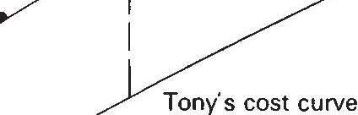60

40

20

12.966 25.932 38.898 51.864

46.0*

Volume

64.830

* 1. Tony's optimization problem. Tony assesses his production costs against the volume, revenue opportunities defined by actual outcomes of frozen pizza producers in the prior production period. Tony chooses the production volume, and associated price, which optimizes the difference between revenue and cost (i.e. profit).

*niches is where it is best suited.* The frozen pizza producers' belief in the market is self-fulfilling, but it is a useful and reasonable belief, since without it they would lack any tangible guidance in choosing a production-pricing strategy.

The market is a simple affair for Tony, which he can use with no mathematical effort. From Tony's point of view, the reliance on tangible price and volume data - not just his own, but also his competitors - is reassuring. The case of using these data enhances their appeal, particularly in com­ parisons to the largely fictional (difficult to utilize) curves of the cconometrician. Tony has little incentive to abandon his particular view of the market as long as it seems to work for him - that is, as long as he is making money.

Exploring the conditions under which markets work, in the sense of market behavior reproducing market structure, requires going beyond Tony's simple point of view. The analytic underpinnings of Tony's market must be developed, so we can understand how distinct roles arc sustained and orderliness is reproduced. We do this in the next section (for a more thorough treatment, see White, 1981a or Leifer, 1985).

# Reproducing structures

## The producer

Tony, and each of the other pizza manufacturers, uses the data of observed volume (y), revenue (W) outcomes from the prior production period to construct a schedule of possibilities for the next period. We refer to this schedule as a W(y) schedule. It is a shared construct among all the producers; they are a closed "clique" in the sense that they know each other's outcomes and use them to define their own possibilities.4

Each producer, however, has his or her own cost curve. These differences in

the cost of production mean that the various pizza makers will come to different volume and revenue decisions. Tony, for example, calculates how much it would cost him to manufacture the number of pizzas that a competitor produces (C(y)). He compares his cost with their revenues (assuming that if he entered their niche, he would be forced [or allowed] to charge their price) and computes his total anticipated profit *in that niche.* If some niche other than his own offers a greater return he must consider a change. The desirability of particular niches will be different for producers with different manufacturing costs than Tony.

In mathematical form, the volume decision is resolved by solving the maximization problem below:

max W(y) - *C;(y)*

*y*

(1)

where *C;(y)* = producer *i's* total production cost for volume *y* and W(y) = total revenues for volume *y* (W(y) is not unique to producer *i,* but rather is a menu shared by all producers). Equation 1 is a mathematical representation of the process illustrated in figure 3.2.

We will approximate the cost curves of the different producers as a family of similar and simple shapes. First, all producers experience the same economies of scale where *c* is a shape parameter that taps economies (c < 1) or diseconomies (c> 1) of scale, and *q* is a scale parameter. To account for differences in the scale of costs, we introduce a cost index *g;* that is unique for each producer *i.5* The cost curves are given the following form:

(2)

where *d* allows the range of cost differentiation fixed by the cost indices (g;) to be stretched or shrunk, and can be positive or negative.6 The need for this stretching or shrinking of cost differences between producers will become apparent when we show how cost differences have to be related to consumer valuation differences for a stable market to be possible.

Maximizing profits (equation 1) is assured when the well-known marginal condition is met:

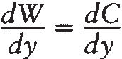(In words, when the slope of the cost curve equals the slope of the revenue curve, marginal cost equals marginal revenue. This can be seen in figure

3.2.) (3)

along with the second order condition (ensuring a maximum as opposed to a minimum):

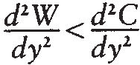**(4)**

In addition, producers require positive profits to produce. These conditions provide a complete specification of the producer's behavior.7 In the real world, each manufacturer can (without fancy mathematics) approximate the profit-maximizing solution for his or her cost curve and pursue that niche.

## The consumer

There is another side to markets, the consumer side. There is always some mystery associated with consumer behavior in differentiated markets, because consumers are so often willing to pay substantially higher prices for a product whose superiority cannot be "objectively" established. The producer never looks directly inside the mysterious consumer.8 Yet consumer behavior in aggregate plays a fundamental role in shaping producer outcomes.

A desirable feature of our model is that producers never have to look past the outcomes of other producers to see the consumer side. The role of the aggregate consumer can be represented as follows. The consumer, for whatever reason, values the different goods (brands) differently, that is, is willing to pay a higher price for some brands than others. As a group, consumers also value different quantities of each good differentially, for example, they may be willing to pay only 50 per cent more for two pizzas than one. This aggregate taste can be expressed mathematically as a collective value consumers receive from the goods of producer i:

(5)

Here *r* is a scale parameter; the exponent *a* relates quantity *(y)* to value; *h;* is a unique "value" index for the good of producer i; and *b* is a parameter that determines the spread for these indices across producers (it can only be positive, due to the convention of assigning a higher value index to producers whose products are perceived as more valuable).9

The consumer makes comparisons across products, and insists that value received bears some relation to dollars given out for each product. If one producer's total offering has less value for the consumer than another's, then the consumer will insist on paying less for the total output. A product which

successfully occupies a niche in a differentiated market must sell for a price appropriate to its (perceived) quality; it must confer the same "value per dollar" as other products. Hence in a stable market, the same ratio (8) of value per dollar holds across all goods, or

*8* S; = *S;* for all goods of producers *i, j* (6)

= W; W;

The stage is set now for showing how the differences in costs and differences in valuations provide the materials for building a stable market. Tony's cost position *vis-a-vis* the other producers and the valuation his pizzas receive *vis-a-vis* other frozen pizzas will "voluntaristically" restrain the niches he can occupy in the market. These positions are set in the g and *h* indices, respectively.

## Tying the sides together

We have now given mathematical expression to both the cost and value elements in differentiated markets. In order for an equilibrium W(y) schedule consistent with these elements to exist, the ordering of producers on costs must be the same as the ordering of their goods on value, though these orderings can be stretched and shrunk or even reversed. This means that either: (1) the producer whose product commands the highest value has the highest costs, the second highest value has second highest costs, etc., or (2) the producer who commands the highest value has the lowest costs, the second highest has the second lowest, etc.

We call this constraint the *coherence condition,* as the constraint is that the two orderings must cohere. Without this coherence the behavior of the producer and consumer sides could not be tied together in a reproducible market, as we will show below. The fact that the elusive "value" to the consumer must be related to production costs is somewhat reassuring. We see this as a reasonable hypothesis about real world economics: *a sustainable market cannot be built among a set of products whose valuations are unrelated to their costs.*

Mathematically, we proceed as follows. The abstract property that lies at the basis of both cost and value differentiation can be called quality. Let *n;* be the quality index for producer *i.* The coherence condition insures that:

*n;* = g; = *h;* for all *i* (7)

So let g and *h* be vectors of indices. The producers insist that (from equations 2 and 3):

-*dC* = *cqyc-1gd* = -*dW dy dy*

i.e. maximum profit. The consumer insists that

(8)



(9)

*dW*= *cqyc-1(0W)dlb*= *cqy((bc-ad)!b)-1(0Wlr)d!b dy ,dlbyadlb*

i.e. competitive value per dollar. Only a market where equations 8 and 9 hold will satisfy both producers and the consumer. The coherence condition implies that the solution for *h* in equation 9 can be substituted for gin equation 8, producing an equation where the abstract quality index disappears. By rearranging the terms in this equation and integrating, a solution can be obtained for W (revenue) in terms of *y* (volume). The W(y) equation is:

W = *((cq(b-d)J(bc-ad))(0/r)dlby(bc-ad)lb+ K)hl(b-d)* (10)

or W = *(Pye+ K)f* with the appropriate substitution for *P, e,* and *f.* Given the context of differentiated costs and valuations (equations 2 and 5, with 7) that characterizes a particular market, the ratio *0,* and the historically determined constant of integration *K,* observed producer outcomes should fall on the W(y) schedule of equation 10. Producers, of course, "see" only the discrete outcomes, and not the W(y) equation.

The crucial interdependence between volume and quality sensed by producers like Tony can be derived by solving the following problem:

d(profits) *dW de*

*dy-*

*dy* = *dy* = *f(Pye+K)f-lPeye-1-cqyc-lnd=* O

to obtain (with substitution for *P, e,* and *{):*

*nb-d* = *(cq0(b-d) I (r(bc-ad))yc-a+ K(0Jr)(b-d)!b/ya(h-d)lh)(ll)*

Given the range of quality indices and contextual parameters, this equation yields the optimal production volumes for producers in a market. (Note that these volumes cannot be obtained through a closed form solution unless *K* happens to equal zero.)

Interpretation

The alert reader might suppose that equations 10 and 11 would relieve a producer like Tony from the task of observing outcomes of other producers. This is not the case, however. The quality index *"n"* will be meaningless to Tony since he is aware of only his own costs, so equation 11 cannot be used to find his optimal volume. The W(y) equation (10) looks more promising, since *"n"* does not appear in it. Even assuming Tony knows the cost and value parameters in equations 2 and 5, however, he could not obtain an analytical solution for his (y,W) decision (with equation 3) because there are two indeterminacies *K* and *0,* which require observational data to obtain. These

indeterminacies imply that the schedule of niches that emerges in any given market will not be uniquely determined by the cost and value context (equations 2 and 5). A range of schedules is possible that all "work" in the sense of both satisfying the producer and consumer sides and being reproduced through the behavior of these sides. Tony, or researchers, cannot predict the exact shape or scale of a schedule in a specific market. *No amount of analytical finesse can relieve Tony of his social interdependence on other producers in defining his "opportunity set," or relieve the researcher of a dependence on data.*

The indeterminacies fit neatly with, and strengthen the case for, our portrait of real world market behavior. In an ongoing market for frozen pizzas (or other products), there are established, discernible niches - for example, a cheap, quick, doughy product may occupy the bottom end of the spectrum, just below the less inexpensive, slightly more time-consuming, very cheesy entry. While it is possible to conceive of an infinity of new products (say a cheaper cheesy pizza), it is impossible to calculate their impact on the current niche structure. It is far simpler to estimate the consequences of invading (or remaining in) an existing niche. That is, producers correctly (from a mathematical *and* practical perspective) rely on the current structure as a frame for decision-making, basing future choices on data derived from the current circumstances of themselves and their competitors.

This raises a new substantive and analytic issue. If both Tony and the

researcher must look at producer outcomes for guidance and parameter estimates, how should this schedule be interpreted? Only a discrete set of outcomes is observed, yet it represents a continuous W(y) schedule. What is the meaning of such a schedule, above and beyond the discrete producer outcomes it is based upon?

To illustrate this issue mathematically, we note that parameter *K* in equation 10 can take on non-zero values. If the continuous *W(y)* schedule had a reality independent from the discrete producer outcomes, one would be led

to the implausible conclusion that producing nothing (y = 0) might yield positive revenue. We are therefore tempted to limit the range of the

continuous *W(y)* schedule to the close vicinity of the actual producer outcomes.

Yet even within a limited range the interpretation of a continuous schedule is not unambiguous. The equation for this schedule (equation 10) has parameters *b* and *d, 0* and *K,* and possibly *r* and *q,* which depend upon a specific set of producers (ns) for their values. A different set of producers (and thus quality index range) would yield different values for *b* and *d,* as well as the other parameters above. Therefore, though producers could assume that any point on the continuous W(y) schedule represents a viable niche, this assumption stands in tension with the dependence of the *W(y)* schedule on a specific set of producers.

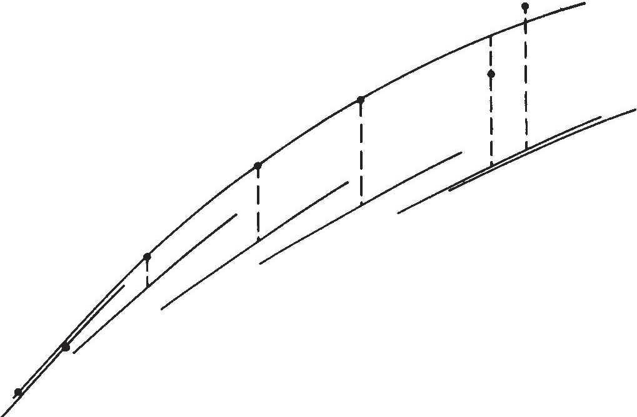80

60

Revenue

40

20

12.966 25.932 38.898

Volume

51.864 64.830

* 1. A self-reproducing market. Each producer uses the shared menu of fates (market outcomes) to select a volume and associated price for the next production period. In a self-reproducing market, their selections will reproduce the menu of fates they used for guidance. That is, they will reselect the niche they occupied in the prior period.

Producers assume they could be anywhere on the W(y) schedule while simultaneously realizing that the schedule itself is built from their own uniqueness. The only situation where these dual beliefs do not stand in contradiction is when the W(y) schedule leads them to reselect their prior niche, and hence reproduce the schedule. We believe that this is a key to understanding the real world conservatism of producers: they have little tangible motivation to step outside of their niche in a reproducible market. Tony produces in a market that continually reproduces itself through the actions of Tony and the other producers, and the mysterious consumer. The production has a structural context, which both guides it and is reproduced by it. To illustrate this reproduction process, figure 3.3 shows some partially simulated data from the frozen pizza market. Each producer is producing at an optimum volume, and therefore chooses to remain in the same niche after each production period. The volumes and revenues suggested by this context serve to reproduce the context (assuming reacceptance by the consumer). The reproduced context can then serve for guidance in the next production period, and so on. Tony is locked into this reproducible structure by his self-fulfilling behavior. He has little incentive to step outside this structure into a setting of

*ex ante* information and expectations.

A possible new entrant into the market, however, must be concerned with

the viability of the untested positions. A continuous schedule implies that any position is viable, yet the schedule itself may have little meaning outside of the set of distinct producers around which it is constituted. To address the issue of *potential* niches, we must look at constraints on aggregate volume and revenue flows.

**Aggregating differentiation**

We must treat aggregate demand in a different way from traditional theory, because we accept qualitative distinctions among the various entries in the market. However, the frozen pizza industry (and other similar sectors) does constitute a market in the sense that entries or exits that affect aggregate flows will affect existing producers in the market. It makes sense, therefore, to ignore the uniqueness of each producer's goods, and to speak of an aggregate demand, even if this total demand depends very much on the specific products offered. If, for example, the cheap, quick, doughy pizza were pulled from the market and replaced by an equally cheap and quick cheesy entry, the aggregate demand might change upward or downward. Therefore, we can speak of aggregate demand, but we must be sensitive to its dependence on the particular schedule of products offered.

The aggregate mechanism is expressed in a satiation,parameter, *y,* which operates on aggregate value in the following way:

Total value= *V* = (E;S(y(n;),n;))Y (12)

Hence a *y* ofless than one means the sum of value obtained from separate goods is discounted. This discounting, however, will affect the ratio of value per dollar (8) through a complex feedback path (see White, 1981a). To illustrate the connection between {Jandy, assume that the market is operating at a level where the total value to the consumer is equal to the total revenue flow (W = I:;S(y(n;))). The 80 associated with this special case is derived in the following manner:

*V* = (I:;S(y(n;),n;))Y = (81:;W(y(n;)))Y = *(JYWY* = *W*

=>breakeven theta = 80 = wU-y)/y (13)

Thus while *y* is not found in the W(y) schedule (equation 10), its influence operates through *{J* and hence can affect the scale of flows in a market.

Entry and exit will be very noticeable events in such markets involving named producers and significant shifts in the market schedule faced by all producers. The ultimate shape of the market is contingent not only on a specific set of unique producers, but also on the aggregate flows they generate. The continuous W(y) schedule that links discrete producers, mathematically given in equation 10, is a fragile construct that has a clear interpretation only

when it functions so as to reproduce itself across periods. Should the producer be guided to shift niches, or a new producer contemplate entering the market, their acceptance would be dependent upon factors only vaguely understood.10 One strength of our model is that it gives considerable leverage over such possible changes. The tools outlined here allow predictions of the conse­ quences of a change in costs or valuations as well as the effects of entry, exit or niche changes. These predictions are illustrated and discussed in Leifer (1985).

# A topology of reproducible structures

Our model can also be used to explore the variety of possible reproducible market structures. Markets can vary widely in the degree to which producers are *spread out* in their costs of production (d) or in the value of their goods to consumers (b). They can also vary in the consequences of *shifting* their volumes on production costs (c) or value to consumers (a). Variation on these spread and shift dimensions correspond to considerable variation in market operation.

There is, therefore, no single type of market, but instead a whole topology of market contexts. Some cost and valuation contexts will not sustain a reproducible market. For example, in some contexts, the perceived compara­ tive value of the products, combined with the cost structures associated with them, lead to an "unravelling" of the W(y) schedule by encouraging producers to seek a corner solution. In these circumstances, we expect that markets do not appear. Conversely, our model predicts reproducible markets where none were thought possible in economic theory, for example in circumstances where it would cost less to produce more - a situation common in real markets. Among reproducible markets, variations will be found in the inequality of outcome (volumes, revenues, profits) between producers, and on basic aspects of market functioning.

In an earlier paper, White (1981a) maps out the cost and valuation contexts that can sustain reproducible markets. Here we focus on a portion of these contexts - those in which it costs more to make higher quality goods - and explore the possible range of inequalities among producers. Though the analytic results we offer are dependent upon a number of simplifying assumptions and specific functional forms, they provide an intriguing glimpse into the variety of reproducible market structures one should expect to find *in* comparative studies of markets.

For present purposes, the topology of reproducible market structures can be represented in two dimensions. The first dimension concerns spreads or, more precisely, a ratio of spreads. This ratio *(bid)* compares the spread of

goods in value to consumers with their spread on costs of production. If the spreads arc equal *(bl d* = l) this means, for example, that if one product costs twice as much to produce as another, consumers perceive it as twice as valuable. A ratio of greater than one *(bid>* 1) means that goods arc more differentiated on value to consumers than they arc on the manufacturing costs for producers, and a ratio of less than one implies the reverse.

In the frozen pizza market, the ratio is greater than one, since valuation differences arc large relative to cost differences. Using a number of guesses in the absence of reliable data, and methods developed elsewhere (Leifer, 1985), we have placed the *bid* ratio for the frozen pizza market around 2.5. (For example, Stouffer's pizza may cost 1.2 times as much as Jeno's to produce, while conferring 1.5 times the value.)

The second dimension concerns shifts. It too turns out to be a ratio. This ratio *(al* c) compares the consequences of shifting production volumes on value to consumers and costs to producers. Stated simply, if overall production were doubled, it might increase production costs by 75 per cent (considering economics of scale). If consumer values increased by 90 per cent for the doubled output, however, then our ratio is greater than one *(ale>* 1). If an increase in production volume increases the dollar value to consumers as much as it increases dollar costs to producers, then our ratio *(al* c) is one.

We have placed the ratio for the frozen pizza market around 1.89 with *c* = 0.9 (unit costs would d_ccreasc slightly with an increase in production volume) and *a=* 1.7 (value to consumers would increase sharply with an increase in producer volumes).

These two dimensions - the spread ratio *(bid)* and the shift ratio *(ale)* define the axes of a topology of market structures. We will focus only on regions that can sustain viable markets in the upper right quadrant. This quadrant is shown in figure 3.4. The frozen pizza market is a solitary point in this quadrant. One can imagine, or discover through comparative efforts, a multitude of diverse markets in different regions of the quadrant. Each market would have its own inequalities and sensitivities, as we will now map out. We limit our attention to the prime regions for stable markets. These correspond to the "STABLE" areas in figure 3.4. In the market region "UNRAVELS" there is a tendency for producers to select corner solutions in their production decisions, and hence "unravel" the volume--rcvcnuc sched­ ule as all producers move toward the same "corner." In the market region "EXPLODES" there is a potential (in certain parameter configurations) for explosive growth11 because companies are monetarily rewarded for increased production. In either instance, though relative niches can be found, there is no stability in the niches sought across production periods. Each company migrates at each decisional juncture. For a more detailed explanation of stable

and unstable regions, sec White (1981a).

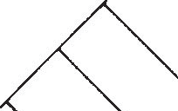bid

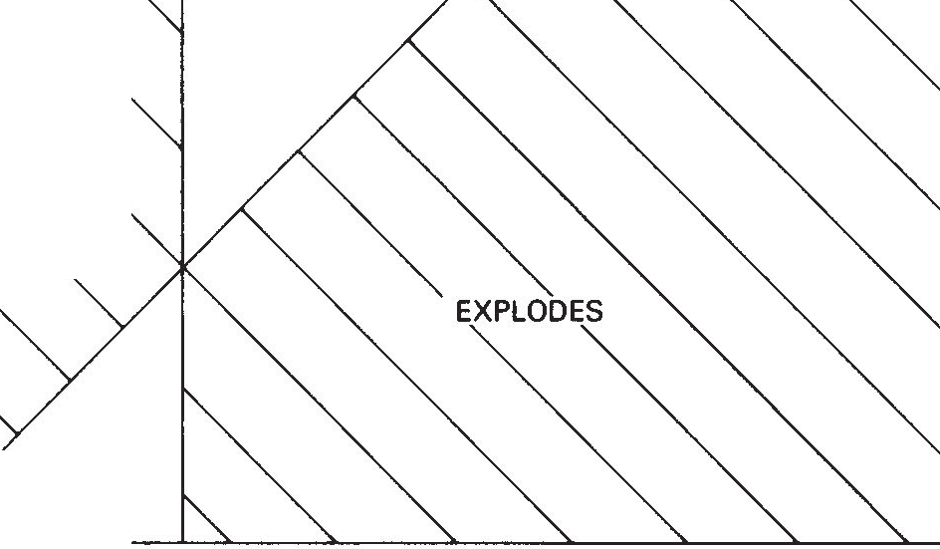

Frozen Pizza Market

X

STABLE

UNRAVELS

STABLE

*ale*

* 1. A topology of market contents. The parameters associated with cost and value contexts define a two-dimensional topology of market contexts. The dimensions are the ratios of spreads on value over spreads on cost between goods, and volume shift consequences on value over volume shift consequences on costs.

Within the stable market region - where firms are constrained to maintain their niches - it turns out that inequality in market (revenue) share depends primarily on the ratio which we call g.

*(b!d)-1*

g = *(alc)-1*

In the shaded region, g is constant across lines passing through (1,1), though it is not defined on (1,1) as here the denominator of *g* is zero. As will become evident, (1,1) is a highly peculiar point in the topology of reproducible markets. It is the point where the spreads and shifts are the same for the producer and consumer sides.

To mathematically explore inequality as a function of g, some simplifying assumptions are necessary. We assume that *K* (see equation 10) is zero, and that producers are spread uniformly across the entire range of *n* (see equations 2, 5, and 7). With these assumptions, an equation for the Gini index, a widely used measure of inequality, which ranges between O (equality), and 1 (maximum inequality) can be derived. The Gini Index, G, is equal to:

.. G 1

G1n1= = 1+_2

(g-l)d

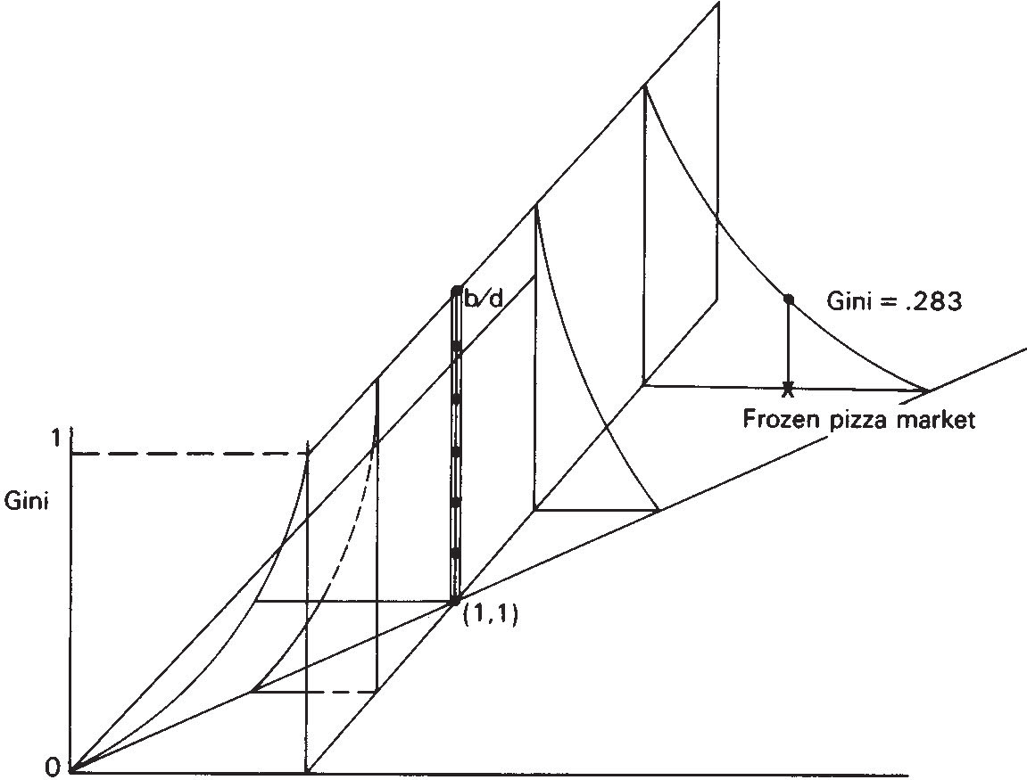

*ale*

* 1. Outcome inequality. Gini measures of revenue outcome inequality are graphed over the topology of stable market contexts. Inequality approaches 1 along the vertical *alc* = 1 (though it is not defined over *ale=* 1). Equality holds where *alc=bld* (i.e. Gini=0). The point (1,1) is a "black hole" where the lines of maximal inequality and equality intersect.

Due to the appearance of *d* in the equation for G, interpretation for inequality in the topology of market structure is the clearest for the limiting cases of 90° and 45° lines running through (1,1). Approaching the 90° line (where *ale=* 1), g heads toward infinity so G heads toward 1, or maximal inequality. Approaching the 45° line, g heads toward 1 so G heads toward 0, or equality. Intermediate values of G between these two limiting lines will, of course, depend on *d,* but given a constant *d,*one gets a gradual transition from maximal inequality to equality as one rotates from the 90° to 45° line through (1,1). Hence there is the full gamut of possibilities for inequality in market share or profits across markets. Figure 3.5 graphs these possibilities, for

*d=* 1.12

To get some intuitive feel for this measure, consider that inequality in pay in a typical business hierarchy of managers might be about 0.2, inequality in earned income in a Western society might run about 0.4, and the Gini for inequality in some major forms of property, say agricultural land in traditional societies or capital ownership in ours, could go as high as 0.8 or more.

The Gini index for actual revenue outcomes in the frozen pizza market is 0.283, a considerable but not extreme degree of inequality. Though the assumptions used to derive the analytical Gini index results are not strictly met in the actual frozen pizza market, the analytically derived prediction for inequality is 0.255, close enough to suggest that the analytic results might be quite robust. The frozen pizza market is demarcated in the sea of possibilities charted in figure 3.5. Each location in figure3.5 carries with it a distinct reality that is analytically sliced from many angles by interested onlookers and lived in by producers like Tony and others. Figure 3.5, however, is offered as a potent illustration that real life diversity may share a common underlying processual logic.

In this section, we have moved a long way from Tony and his operating concerns. Tony makes his production decisions in the framework defined by the decisions of other producers, whose products and production options are comparable, but differentiated, from his. Tony and the other frozen pizza producers share a common context of costs and valuations which shapes the way their market will function and respond to exogenous changes, and which shape the inequality in their outcomes. In this section, we have moved to the level of a topology of market contexts in which diverse markets can be placed. The basic structuralist credo holds at this level with equal force: position in a topology of market contexts constrains the functioning of a market, just as position in a market constrains ("voluntaristically") the decisions of producers.

# Discussion

The model presented here defines the structural context of producers by referring to the relations among producer outcomes. The shape and location of the structural context of market activity are dependent on specific sets of producers, and cannot be defined apart from them. The structural context of a schedule of niches sums up market possibilities and thereby provides a guide for producer behavior. In a viable market, producer behavior is guided in such a way that it functions to reproduce the structural context from which it derives. Our model provides the conceptual and mathematical conditions for self-reproducing structural contexts, and thus delimits the variety of markets which can be empirically observed. Reproducibility therefore becomes the central issue in characterizing markets and understanding market behavior. In this section, we contrast this structural approach with the information orientation which dominates economic analyses of markets.

Information approaches are driven more by the questions producers ask than the way they go about answering them. Each producer, in a differentiat­ ed market, wants to know the unique demand curve for his product. That is,

he wants to know how much he can sell at any given price. Furthermore, the producer's questions are asked in *ex ante* terms- he wants to know what *will* happen. Given this question, economists and marketing consultants have focussed on the kinds of information and theories needed to provide an answer. Firm-specific demand curves can be estimated from prior firm outcomes, yet this estimation depends on the assumption that the demand curve *does not change (or changes predictably) over time* (lntriligator, 1978), *and such estimation ignores interdependencies between producers.*

lf these interdependencies are to be taken into account, assumptions must be made about how other producers *will* react to the focal companies' price­ quantity decision, and further assumptions must be made about the cross­ product elasticities which guide the consumers' selection among producer offerings. An *ex ante* focus on all these interdependencies requires much more information and many more theories to define the possibilities that face each producer. An answer to the simple question asked by producers therefore invariably requires invoking a whole series of assumptions which inspire little confidence because they are based on mathematical convenience rather than empirical plausibility. A definitive answer has therefore not been found, and if left to be provided by the theory of games, it does not look like one will be found (see Shubik, 1982; Smith, 1982).

One might wonder why the producer's simple question is so central if the solution is intractable, or at best dependent on such arbitrary assumptions? Producers, after all, seem to function in the absence of a clear answer, and few would claim that markets must be fully understood (in the form of explicit theory) in order to operate.

A solution to this dilemma comes from recognizing the link between the producer's question and the idea of efficiency. If we view the producer as situated in a visible spectrum of evaluatable alternatives, efficiency can become a relevant concern. The wider the range, the more relevant is the idea of efficiency in rationalizing actions (see Granovetter (1985) for a critique of the centrality of efficiency in economic thought). Answers to the question of what will happen must cover all real world possibilities for efficiency to be relevant. The producer's ultimate choice must be set against a backdrop of possible, yet less desirable, behaviors. This circumstance simply does not occur in the real world.

The problem with focussing on the hypothetical producer's question is that it stands in the way of discovering any distinct reality associated with a "market." Firm-specific demand curves divert attention from markets altogether. Yet the producer's reputation, behavior, and possibilities may be defined, as we have claimed, purely from the standpoint of the producer's relation to other producers in a "market." These relations are knowable (observable) only *ex post,* from market structure, or what has worked in past periods. An "orderly" market structure therefore reflects the inter-

dependencies in the market, *ex post.* When the producer is viewed from the standpoint of the market, these "ex post" interdependencies - already observed in the previous production period - replace speculated gaming interdependencies and cross-product elasticities -which are assumed in some *a priori* manner.

The producer's position and possibilities are defined in terms of these *ex post* interdependencies that make up market structure. This central feature of structural analysis is lost when we lock ourselves inside a hypothetical producer's *ex ante* point of view and attempt to depict *ex ante* possibilities that lie outside of observed *ex post* interdependencies. In our structural approach, producer behavior can be understood only from the point of view of the market. The "market" assumes a distinct reality of its own, and it provides guidance to producers. Rather than being a consequence of solutions to producers' *ex ante* speculations, it is an empirical premise derived from past production periods.

In stepping outside a hypothetical producer's *ex ante* point of view, efficiency ceases to be well defined. A wide range of market structures becomes possible for any particular set of producers, the particular structure that appears being partly determined by historical accident (K) and scale indeterminacies (8). The varying structures will be associated with varying levels and dispersions of profits across producers. In most cases, producers will make positive profits; and different profit levels will exist across producers as stable features of the market. The "zero profit" criteria for "equilibrium" markets that economists insist upon has no place in the proposed structural approach. The positions of producers in a market, with their distinct profitability implications, must be treated as givens. For this treatment of position to be useful, positions must be stable, else the structural context of interrelated positions could not provide a useful source of guidance.

Reproducibility, not efficiency, is the relevant issue in structural analysis.

The range of possibilities is defined by the structures in which position holders operate. It does not extend beyond these *extant* structures, as would be needed to assess the abstract efficiency of a structure. Given the narrow and well­ defined range of possibilities that defines a reproducible structure, the behavior of position holders is self-fulfilling. It functions to maintain their position within the structure. Figure 3.4 showed that not all imputed market structures are reproducible in this sense. Clearly if the behavior of "position holders" serves to undermine positions and structure, then the reality of "position" and "structure" as observer constructs must be suspect.

In our model, markets are real structures with definite boundaries. Producers are position holders whose behavior reaffirms their position in the market, marked by a distinct reputation in the "culture" associated with a market. Positive and unequal profits are facts-of-life institutional details for

most markets. This treatment of markets as real structures contrasts sharply with the (neoclassical) economist's treatment of markets as a convenient analytical device for drawing inferences about the "economy," or systems of markets. It also contrasts with most applied economics treatments (e.g. Porter, 1980), which treat markets as loosely defined arenas for strategic *(ex ante)* ploys. Our model tries to combine some of the analytical rigor of the economist with some of the institutional realism of the business professor. Markets become a realistic device that can be used by concrete producers and studied by researchers.

NOTES

Financial support from the University Research Council of UNC is gratefully acknowledged. This chapter has benefited from the extensive editorial efforts of Mark Granovetter, Mark Mizruchi, and Michael Schwartz.

1. It should be stressed that, unlike functionalism, structural analysis does not assume that a social arrangement is self-reproducing. Integral structural contradictions can produce ongoing conflict and change - or even destruction - of a social institution. This point is elaborated below.
2. We assume Tony treats the retail customer as the "consumer," as opposed to the distributors and/or retail outlets which buy pizzas directly from him. Tony allows a standard markup for these outlets in arriving at the price he will charge them, and thus absorbs the costs and benefits from market fluctuations. Other arrangements are certainly possible. Defining the "consumer" must involve careful consideration of the distribution channels for a product, with regard to the pricing, packaging, and marketing responsibilities of each concern that handles the product.
3. Since revenues equal price times volume, this is analytically identical to describing the dimensions as volume and price. In our formulation, we use *y* (volume) and W (revenue).
4. In advocating structural over information approaches, our argument largely rests on the "publicness" of information and not its presence or absence. The advantage of the proposed structural approach is that it assumes actors act on the basis of information that is readily obtainable, through informal communications, trade association publications, marketing reports, and the like. (We do not assume a producer knows the other producers' costs, which are not easy to obtain - and presents difficulties for the researcher in estimating parameters for a market.) Information approaches, in adopting an *ex ante* point of view, rend to freely assume the availability of "private" information that has no tangible existence in the producer's operating world.
5. We treat cost differences as exogenously determined. They could result from the use of different production techniques, factors of production, labor rates, locations, etc. If one envisions, however, the formation of a market as a trial and error process, where products and images are put before the consumer and either received or rejected, initial cost differences might be related to initial role perceptions of the producers. That is, the producer who perceives he is slipping into

a definite market role (e.g. as a high-quality producer) may alter his product or its image (e.g. packaging), and hence its costs, in a way that conforms to the perceived role. Cost differences, and their relation to valuation differences (see below), cease to be so mysterious when viewed in this light.

1. To get unique estimates for *g* and *d,* the range of *g;* must be arbitrarily fixed. The interval selected for the lowest and highest *g* will determine how *d* is interpreted (e.g. if a "large" interval is selected, then a "small" *d* may still mean there is some differentiation in cost structures between producers).
2. The second order condition ensuring maximization (equation 4), and the condition that producers require positive profits to produce correspond to the satisfaction of the two inequalities below:

*(cd(a* - *c)!(bc- ad))y(bc-ad)lb* > - *adK!bq(0/r)dlb*

*(d(a- c)l(bc-ad))y(bc-ad)!b* > - *Klq(0/r)dlb*

1. This assumption obviously downplays the importance of marketing research in production and pricing decisions within a stable market context. Much marketing research, however, is used for other purposes anyway, like exploring potential market areas or at least legitimating already made decisions to enter new areas. If some routine production and pricing decisions are based on marketing research, the .error that might be introduced in ignoring this research (assuming its conclusions differ from those of the unaided producer) is small, we claim, relative to the error and intermediacy we would face in conceding that production and pricing decisions *are* based on marketing research.
2. Value can be viewed as measurable in dollar units. In discussing aggregate value and revenue later, we suggest the assumption that aggregate value equals aggregate revenue provides a convenient calibrating device. Thus if $240 million is spent on frozen pizzas annually, we assume that all the frozen pizzas purchased are "worth"

$240 million to the aggregate consumer. The difficulties entailed in actually measuring this "worth" motivated the first author to design techniques for estimating market parameters without directly measuring value (see Leifer, 1985). The researcher, however, has to make an assumption about how much valuations differ across products (b) and, without data for multiple production periods, an assumption about the aggregate satiation (y), a factor discussed later.

1. This imagery stands in sharp contrast to the fluidity of competitive markets in economics (aside from Chamberlain, 1933), where only the aggregates matter. The distinct reputations of producers are not "frictional" effects in the W(y) model, but the basic building blocks of markets.
2. This potential is dependent upon *al c* being greater than *1/y.* The *y* dimension, however, can be suppressed for present purposes.
3. The point (1,1) is a sort of "black hole" in the topology of market structures. It is the point where the lines of maximal inequality and equality intersect, and hence represents a most peculiar situation. Mathematically, a Gini index is not defined at the (1,1) point, and no stable market is possible there either. At the (1,1) point, spreads on cost and value between producer goods are identical for producers and consumers, respectively, as are sensitivities to shifts across production volumes.

Why this symmetry in spreads and shift sensitivities between producer and consumers precludes a stable market is a puzzle we must leave to the reader to solve. The solution to this riddle may give insight into the prerequisites for interfaces in general which tie together two distinct sides.

REFERENCES

Berkowitz, S. D., 1982. *An Introduction to Structural Analysis: The Network Approach to Social Research.* Toronto, Canada: Butterworths

Boorman, S. A., 1975. "A combinatorial optimization model for transmission of job information through contact networks." *Bell Journal of Economics,* 6 (Spring): 216-49

Breiger, Ronald, 1981. "Structures of economic interdependence among nations." in P. M. Blau and R. K. Merton (eds.), *Continuities in Structural Inquiry.*

Beverly Hills: Sage, pp. 353-80

Burt, Ronald S., 1982. *Toward a Structural Theory of Action: Network Models of Social Structure, Perception, and Action.* New York: Academic Press

Chamberlain, Edward H., 1933. *The Theory of Monopolistic Competition.*

Cambridge, Mass.: Harvard University Press

Granovetter, Mark, 1985. "Economic action and social structure: the problem of embeddedness." *American Journal of Sociology,* 91: 481-510

lntriligator, Michael D., 1978. *Econometric Models, Techniques, and Applications.* Englewood Cliffs, N.J.: Prentice-Hall

Kanter, Rosa beth Moss, 1977. *Men and Women of the Corporation.* New York: Basic Books

Leifer, Eric M., 1985. "Markets as mechanisms: using a role structure." *Social Forces,* 64 (2) (December): 442-72

Lorrain, F. P., and Harrison C. White, 1971. "Structural equivalence of individuals in social networks." *Journal of Mathematical Sociology,* 1 (January): 49-80

Love, Geoffrey, 1982. "An investigation of block-modeling techniques applied to international trade flows." Unpublished undergraduate thesis, Harvard University

Miller, Ross M., and Charles R. Plott, 1983. "Product quality signaling in experimental markets." Working Paper No. 40/82, School of Management, Boston University

Porter, Michael E., 1980. *Competitive Strategy.* New York: Academic Press

Riley, John G., 1975. "Competitive signalling." *Journal of Economic Theory,* 10: 174-86

1979. "Information equilibrium." *Econometrica,* 47: 331-59

Shubik, Martin, 1982. *Game Theory in the Social Sciences.* Cambridge, Mass.: MIT Press

Smith, Alasdair, 1982. *A Mathematical Introduction to Economics,* Totowa, NJ: Barnes and Noble

Snyder, David, and Edward L. Kick, 1979. "Structural position in the world system and economic growth, 1955-1970: a multiple network analysis of

transnational interactions." *American Journal of Sociology,* 84: 1096-126 White, Harrison C., 1963. *An Anatomy of Kinship.* Englewood Cliffs, NJ:

Prentice-Hall

1981a. "Production markets as induced role structures." In S. L. Leinhardt (ed.), *Sociological Methodology.* San Francisco: Jossey-Bass, pp. 1-57

1981b. "Where do markets come from?" *American Journal of Sociology,* 87: 517-47

1987. "Varieties of markets." In Barry Wellman and S. D. Berkowitz (eds.),

*Structural Sociology.* Cambridge University Press (in press)

Williamson, Oliver E., 1975. *Markets and Hierarchies: Analysis and Antitrust Implications.* New York: The Free Press

Winship, Christopher, 1978. "Allocation of time among individuals." In Karl F. Schuessler (ed.), *Sociological Methodology.* San Francisco: Jossey-Bass, pp. 75-100